# Roadshow 2017

Discover a world of opportunities for your educational journey at ‘Roadshow 2017’.

For the first time in India, the Embassy of Italy in India along with Uni-Italia will be organizing ‘Roadshow 2017’ in four major cites of the country, namely, New Delhi, Mumbai, Bangalore and Kolkata.

Representatives of numerous Italian Universities will be visiting the four cities bringing forth the richness of culture and learning one can find in their renowned educational establishments.

The Roadshow will give access to Graduate and Post-Graduate students to gain information about the various courses offered by the Italian Universities directly from the University representatives themselves.

Most Italian Universities being public and state affiliated offer quality education at a cost which keeps in mind the students’ economic status.

With the benefit of availing merit scholarships granted by the Universities and the Italian government, a chance to study in Italy is a gift in itself. Not only can you bathe in the scenic beauty of the historical country while flipping through the pages of your textbook, but you get to learn from the masters in the field of Art, Design and Science.

So dear students, what are you waiting for? Don’t you think it’s high time you pack your bags to go and study in Italy? Come visit us at the Roadshow to know more about the opportunities that await you at the other side of the world!

# The Journey

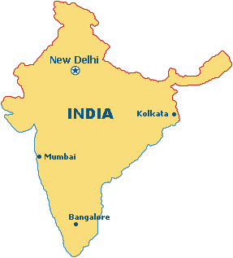

Landing in Mumbai on the 23rd of November 2017, the participants of the Roadshow will have a split up between Bangalore and Kolkata following which they will slowly make their way from there to Delhi.

# Schedule

|  |  |  |
| --- | --- | --- |
| City | Date | Venue |
|  |  |  |
| Mumbai | 24th Nov – 25th Nov ’17 (Fri – Sat) | University of Mumbai & K J Somaiya Institute of Management Studies and Research |
| Kolkata | 27th Nov ’17 (Mon) | Italian Consulate |
| Bangalore | 27th Nov ’17 (Mon) | Christ University |
| New Delhi | 28th Nov ’17 (Tue) | Italian Cultural Centre |

# Benefits for the Students

* A chance to meet the best Italian Universities under one roof
* Direct interaction with the University representatives
* In-depth transparent information about courses, benefits and scholarships
* Learn about the visa policy for studying in Italy
* Get guidance and counseling for planning a better future
* Testimonials from people who have studied in Italy and well-settled in India

# Registration

Register yourself for the Roadshow at: <https://www.eventbrite.it/e/roadshow-2017-italian-universities-in-india-consulate-general-of-italy-registration-39549489588>

No entry fee required!

**Kolkata**

# Participating Universities

* Albertina Academy of Fine Arts, Turin
* Brera Academy of Fine Arts, Milan
* Polytechnic University of Milan
* Università degli Studi di Firenze
* University of Rome "la Sapienza"

# Venue Details

|  |  |  |  |
| --- | --- | --- | --- |
| **Date** | **Venue** | **Address** | **Time** |
|  |  |  |  |
| 27th Nov ’17 (Mon) | Consulate Garden – Consulate General of Italy in Kolkata | 5G, New Road, Alipore, Kolkata - 700027 | 09.00 – 13.30 |